ACHARYA SHANTI SAGAR FOUNDATION
Preserving Wisdom • Uplifting Communities • Keeping a Timeless Way of Life Alive
Guided by the Jain philosophy of non-violence, truth, and conscious living

(The details of these topic should go on about us ddpage )
MISSION
To guard what is ancient, serve what is present, and build what is needed
The Foundation is committed to preserving and promoting the Jain philosophy of conscious, compassionate, and non-violent living — a way of life refined over millennia and encoded in ancient manuscripts, sacred texts, and an unbroken tradition of ethical inquiry. We believe that the Jain principles of Ahimsa, Satya, Aparigraha, and Anekantavada offer not merely a religious identity but a complete and timeless guide to how human beings can live with integrity, simplicity, and deep regard for all life.
We are equally committed to ensuring that this philosophy lives not only in texts and temples but in people. We work to expand access to quality education for young members of our community, foster self-reliance among underprivileged Jain families, and preserve the ancient manuscripts and scholarly heritage that carry this philosophy forward. In every initiative, our measure of success is simple: are more lives being touched by the transformative power of Jain thought.

Ancient Manuscript Preservation | Philosophy-Rooted Education | Community Self-Reliance | Conscious Living | Rural Infrastructure development

VISION
A world shaped by the Jain way of conscious, compassionate living
We envision a society where the Jain way of life — grounded in non-violence, truthful speech, mindful consumption, and respect for the multiplicity of perspectives — is not a relic of the past but a guiding force in the present. A world where ancient manuscripts and philosophical texts are not lost to time but preserved, studied, and made accessible to scholars, students, and seekers across generations.
We envision every Jain child, regardless of family circumstance, growing up with access to an education that is both intellectually empowering and rooted in the values of Ahimsa and Satya. We see underprivileged members of our community not as recipients of charity but as individuals empowered by knowledge, skill, and solidarity to build self-sufficient, dignified lives. This is a community where the philosophy of Jainism ceases to be inherited passively and begins to be lived consciously — as a complete, beautiful, and deeply human way of being in the world.

VALUES
Five principles, one way of life

Ahimsa | Non-violence as the highest principle  Every decision, every programme, every relationship begins with the question: does this cause harm? Compassion for all living beings is not an ideal we aspire to — it is how we operate.

Satya | Truth as a living practice  We preserve ancient knowledge without distortion, serve communities without pretence, and hold ourselves to complete transparency — because truth is not only what we teach but how we live.

Aparigraha | Enough is a philosophy  We are guided by the Jain understanding that accumulation beyond need diminishes the soul. All resources entrusted to us flow directly toward education, heritage, and community upliftment.

Anekantavada | Many truths, one community  The Jain philosophical insight that truth is many-sided shapes how we engage — across sects, regions, and backgrounds — with humility, openness, and genuine respect for every perspective.

Karuna and Seva | Compassion without condition  The Jain way of life calls us not to withdraw from the world but to serve it. We translate philosophy into action — in classrooms, communities, and the quiet work of preserving what must not be lost.

* Heritage Preservation  Restoring, digitising, and protecting ancient Jain manuscripts so a philosophy thousands of years in the making endures for thousands more. | * Education Support  Scholarships and learning opportunities rooted in both modern knowledge and the Jain values of inquiry, discipline, and conscious thought. | * Community Self-Reliance  Skill-building, livelihood support, and welfare for underprivileged Jain families — empowering dignity, not dependence. | * Conscious Living  Promoting the Jain way of life — mindful consumption, ethical relationships, and simplicity — as a practical path for individuals and families today.

“Parasparopagraho Jivanam”
All life is bound together in mutual support.
We preserve ancient wisdom not as memory, but as a living invitation — to think differently, live consciously, and act with compassion toward every soul.

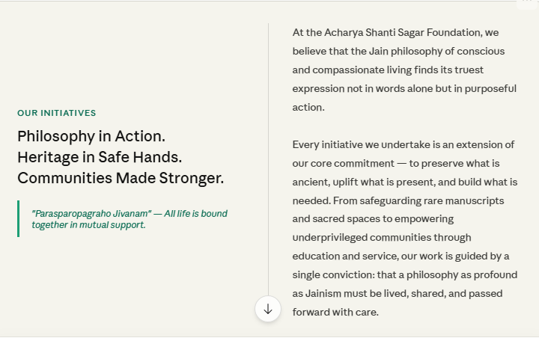

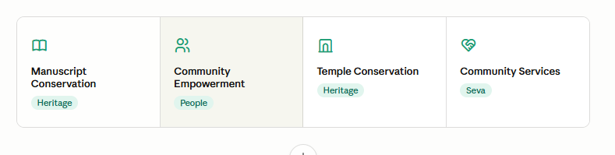

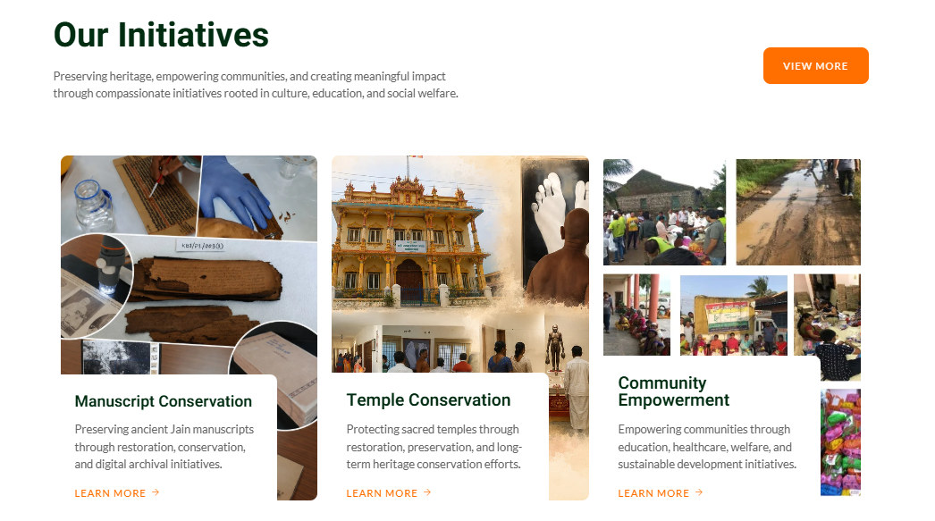

Instead the above title and below lines, need to put the below mentioned text.

From Vision to Reality

We believe that values are only real when they're lived. Through four interconnected areas of work, we translate our commitment to wisdom, dignity, and compassion into tangible action that touches real lives and strengthens real communities.

(Below mentioned detailed part will go on about us page.)

- From Vision to Reality
Four Areas of Impact: Detailed Descriptions

Manuscript Conservation
Safeguarding Wisdom Across Centuries

In temples, monasteries, and heritage libraries across three Indian states lie treasures that represent humanity's collective effort to understand ethics, philosophy, science, and the nature of conscious living. These ancient manuscripts—some over a thousand years old—contain the accumulated wisdom of generations. Yet they face irreversible deterioration. Without intervention, they will vanish silently, page by page. This is not merely about preserving old books. It is about preserving knowledge that remains relevant—and vital—to how humans can live together with integrity, compassion, and wisdom.

The Scale of the Challenge
Between 2023 and 2024, we conducted the first comprehensive field survey of manuscript collections across Karnataka, Maharashtra, and Tamil Nadu. Led by conservation professionals with expertise in heritage preservation, the survey documented manuscripts held in temples, monasteries, and research institutions.
Total manuscripts identified: 11,397
Total folios (pages) awaiting conservation: 16,17,848
Major collection sites surveyed: 15
Palm-leaf manuscripts: 8,167 texts with 13,18,549 folios
Handwritten paper manuscripts: 3,030 texts with 2,73,099 folios

What We Found
In nearly every location, custodians expressed genuine reverence for the manuscripts. Yet almost universally, they lacked the technical knowledge and resources for scientific preservation. The consequences were evident: brittle palm leaves breaking at touch, insects consuming pages, moisture causing deterioration, ink fading beyond legibility, fragile bindings failing. Many manuscripts were stored in unsuitable conditions. The situation demanded urgent, systematic intervention.

Our Scientific, Rigorous Approach
We did not rush into conservation. We built a foundation of expertise, partnerships, and methodology ensuring our work met the highest international standards.

Partnership with India's Leading Conservation Organization
We established formal partnership with Gyan Bharatam—India's premier institution for manuscript conservation. This partnership provides structured training, technical mentoring from expert conservators, access to latest protocols, financial support, and ongoing capacity development. We became the second MCC-certified conservation center in Karnataka, ensuring alignment with national heritage preservation standards.

Building a Skilled Team
We employ Lead Conservators, Assistant Conservators, Interns, and fresh graduates at industry-standard salaries. This approach strengthens our projects while building long-term capacity in conservation—addressing the scarcity of trained conservators in India. We are investing in the profession itself.

The Nine-Step Conservation Process
- Detailed assessment and documentation
- Dry cleaning of surfaces
- Folio strengthening and reinforcement
- Deacidification and chemical stabilization
- Repairs and careful mending
- Separation of stuck folios
- Humidity and pest control
- Cataloguing and archival housing
- High-resolution digitization

From Vision to Reality: Completed Projects
Bahubali Siddhopeth Granthalaya, Kumbhoj, Maharashtra
Our flagship project: February 2022 – September 2024. Kumbhoj, a revered pilgrimage site in Kolhapur district, housed an extraordinary collection of ancient manuscripts. Environmental exposure had left many in fragile condition.
Our team of 15+ conservation professionals conserved 1,399 manuscripts with 1,06,277 folios: Palm-leaf (122), Paper manuscripts (1,018), Archival books (259). We completed 100% digitisation, implemented the full nine-step workflow at every stage, built local capacity for preventive care, and created organized bilingual catalogues. Total investment: ₹1,13,56,102.
This project demonstrated that rigorous, scientific conservation could succeed in traditional, community-run repositories. It set the standard for all future work.

Mahaveer Gurukul Ashram, Karanja Lad, Maharashtra
Following success at Kumbhoj, trustees at other institutions approached us. Mahaveer Gurukul Ashram holds collections dating from 12th-20th centuries—palm-leaf granthas, handmade paper manuscripts, rare archival books, handwritten notes in multiple scripts.
Project duration: October 2024 – August 2025. Conserved 221 manuscripts with 28,268 folios. The collection presented significant challenges: brittle paper, stuck folios, multiple ink types, insect damage, fungal staining, structural loss. Our team addressed each through tailored treatment. Materials: Palm-leaf (4, 60 folios), Paper (189, 20,524 folios), Books (28, 7,684 folios). Investment: ₹36,96,316. Digitisation planned for 2025.

Current Active Projects (April 2026)
Karanja Lad Multi-Temple Expansion
Building on success, we expand conservation across three major temples in Karanja Lad. Status: Completed at MD Asharam | In progress: Mulsang Balatkar (2,893+ folios, 30 illustrated manuscripts) | Planned: Kastha Sang Temple. Coordinator: Alka Mehta | Lead Conservator: Kartick Kayal

Shravanabelagola NIPSAR Prakrit Bhavan
Shravanabelagola—one of history's most significant centers for manuscript preservation. For nearly two millennia, this site has safeguarded intellectual heritage. Our conservation work at NIPSAR's Prakrit Bhavan protects this irreplaceable inheritance. Current work: restoration of ancient manuscripts, removal of deteriorated materials, mending of fragments, meticulous documentation. Collections represent centuries of scholarship, philosophical inquiry, and regional literary traditions in multiple languages.

Why This Work Matters
Manuscript conservation is resource-intensive. Each folio requires expert knowledge, archival-quality materials, meticulous handling. When successfully conserved and digitised, a manuscript is rescued from irreversible loss and made accessible to researchers and seekers for generations. The wisdom it contains—about ethics, non-violence, truth, and conscious living—remains available to guide those seeking understanding. This is not about the past. It is about ensuring the future has access to knowledge that remains profoundly relevant.

Temple Conservation
Preserving Sacred Spaces Where Communities Gather
Walk into a historic temple, and you enter a space that carries centuries of memory. The stone beneath your feet was laid by hands long gone. The carvings on walls tell stories that have inspired countless seekers. The architecture itself embodies principles of harmony, proportion, and spiritual understanding refined over generations. When such a space deteriorates—when walls crack, roofs leak, carvings crumble—we lose far more than a building. We lose a tangible connection to our past, a sanctuary where present and future generations can experience the values and beliefs of their ancestors.
Why Temple Preservation Matters
Temples serve multiple critical functions in communities:
- Physical Anchors of Memory: Historic temples are living records of community history, artistic achievement, and spiritual aspiration. They connect people to their past and provide continuity across generations.
- Repositories of Artistic Heritage: Temple architecture, sculpture, and ornamentation represent centuries of artistic evolution and craftsmanship. Their loss means losing a chapter of human artistic history.
- Spaces for Spiritual and Community Practice: Temples serve as places where people gather for prayer, celebration, learning, and community bonding. Deterioration compromises this function.
- Living Heritage: Unlike historical documents, temples must remain functional. Conservation means preserving them as living institutions, not freezing them as museum pieces.
Our Conservation Philosophy
Temple restoration is complex work requiring expertise across multiple disciplines: structural engineering, architectural history, traditional construction methods, materials science, and community engagement. It demands humility—respect for what came before and commitment to preserving it faithfully.
Rigorous Structural Assessment
Before any restoration work begins, we commission detailed structural evaluations by qualified engineers and heritage conservation experts. This assessment identifies root causes of deterioration, determines structural integrity, and informs a scientifically sound restoration plan. Work is planned based on engineering necessity, not aesthetics alone.
Phased Implementation
Large restoration projects are divided into manageable phases spread over time. This approach allows communities to bear costs gradually, minimizes disruption to ongoing temple activities, and permits regular reassessment as work progresses. Phased work also allows communities to participate in fundraising and decision-making at each stage.
Preservation of Authenticity
We work with skilled artisans trained in traditional techniques to restore carvings, sculptures, and ornamental elements. Modern conservation science is used to stabilize and preserve, but the goal is always to restore what was there—not to recreate or reimagine, but to return to original condition as faithfully as possible.
Community Partnership
Temple restoration succeeds only with genuine support and participation of the community that uses the space. We work closely with temple committees, local authorities, custodians, and lay members to ensure plans are transparent, respectful of community values, and sustainable long-term. The community must understand and support the work.
Functional Modernization
Temples must remain functional as places of worship and community gathering. We carefully upgrade essential facilities—water systems, sanitation, electrical safety—while maintaining architectural and aesthetic integrity. The goal is to preserve heritage while enabling the space to serve contemporary communities.
Current Focus Areas
We are currently identifying temples across Karnataka and Maharashtra that require conservation support. Our priorities include:
- Historic temples facing structural deterioration from age, weathering, or poor quality past repairs
- Temples with significant architectural or artistic heritage at risk of permanent loss
- Community-managed temples that lack technical expertise or financial resources for preservation
- Temples serving as active spiritual and cultural centers requiring restoration
A Long-Term Commitment
Temple conservation is not quick or inexpensive. It requires significant financial investment, specialized expertise, patient planning, and sustained commitment. By supporting this work, you help ensure that sacred spaces built with devotion by ancestors continue to serve spiritual, cultural, and community purposes for centuries to come. You help preserve not just buildings, but the continuity of meaning and memory that flows through generations.

Support Us…

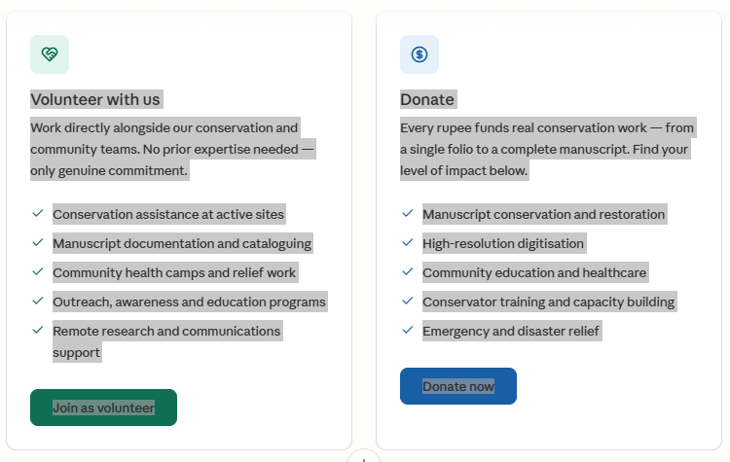

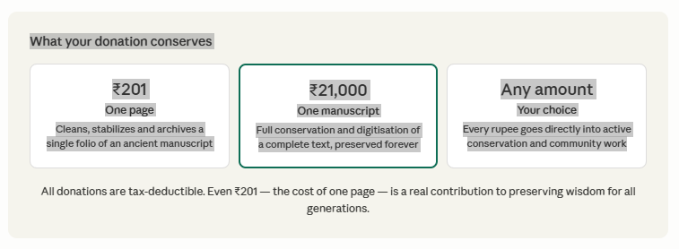

Community Empowerment & Services
Where Planning Meets Action
True compassion does not create dependence. It puts people on their own feet. We recognize that families face different barriers—lack of education access, absence of marketable skills, inability to start businesses, health crises, unexpected disasters. We address these through an integrated approach: planned, comprehensive empowerment programs combined with immediate, on-ground community services that meet urgent needs today.
PART A: COMMUNITY EMPOWERMENT INITIATIVE (Planned & In Development)
Our Community Empowerment program is currently in detailed planning phase. We are designing a comprehensive, integrated scheme that will transform how we support underprivileged families. Rather than scattered assistance, we are creating a structured pathway to self-reliance.
The Blueprint: Six-Pillar Empowerment Scheme
1. Education Loan Program
Providing educational loans to meritorious students from economically weak backgrounds who would otherwise be unable to afford quality education. Loans cover: school, vocational training, undergraduate, specialized courses. Terms: Interest-free or low-interest with flexible repayment after completion. Selection: Merit-based from families below the poverty line. Impact: When one person is educated, they become an agent of change in their entire family and community.
2. Skill Development & Vocational Training
Partnering with training institutes to provide market-relevant skills that lead directly to employment. Focus areas: IT, healthcare, hospitality, construction trades, agriculture, retail. Program duration: 3-12 months depending on field. Support: Job placement assistance upon completion, living stipend during training period. Our approach ensures economic barriers do not prevent participation.
3. Small Business Support Program
Helping individuals establish small businesses with comprehensive support: training, micro-loans, mentoring. Business types supported: Retail, service, agriculture-based, artisan-based, home-based. Loan structure: Up to ₹1,00,000 with flexible repayment terms. Training: Business planning, financial management, market linkage. Ongoing mentoring: Two years of support during critical early operation phase.
4. Women Entrepreneur Setup Support
We recognize particular barriers women face in establishing enterprises. Our dedicated women entrepreneur program includes: Prioritized loans up to ₹1,50,000 with minimal interest. Women-focused training in entrepreneurship, financial literacy, digital skills. Community entrepreneur networks for peer learning and mutual support. Childcare assistance during training and early business phases to remove logistical barriers.
5. Healthcare & Nutritional Support
Health is foundational to empowerment. We provide: Basic health insurance coverage for selected families. Financial assistance for emergency medical treatment. Nutritional support programs for school children and pregnant mothers. This ensures families do not face catastrophic health expenses that undo economic progress.
6. Emergency Assistance for Crisis Situations
We provide emergency support during unexpected crises: Disaster relief during natural calamities. Financial assistance for critical health situations. Support for families facing job loss or sudden economic hardship. This safety net prevents families from falling further into poverty during vulnerable moments.
Impact & Tracking Framework (Under Development)
We are designing comprehensive tracking systems to measure real impact: Employment achievement rates among skill-trained individuals. Business success and sustainability rates among micro-entrepreneurs. Education completion rates among loan recipients. Family wellbeing improvements in income, housing, healthcare access, and children's education. Long-term follow-up to understand multi-generational impact.
Implementation Timeline & Rollout
The Community Empowerment Scheme is being structured for phased rollout. We are currently: (1) Completing detailed program design and operational procedures, (2) Identifying partner institutions and training providers, (3) Establishing assessment and tracking systems, (4) Building partnerships with local communities and gram panchayats. Launch is planned for [timeline to be confirmed with foundation]. Initial focus will be on [geographic areas and community groups identified].
PART B: COMMUNITY SERVICES (Currently Operational)
While we develop the comprehensive empowerment program, we are actively providing urgent, immediate support to communities through on-ground services. These programs address pressing needs today while we build infrastructure for long-term empowerment tomorrow.
Healthcare Programs
We organize regular free medical camps in underserved areas, bringing together qualified doctors and specialists to provide preventive care, diagnosis, and treatment.
Irkal Village, Raichur — Beneficiaries: 463 | Specialties: Cardiology, Nephrology, Neurology, Ophthalmology | Free surgeries: 5 heart bypasses, 35 cataracts
Dadagadapura, Mandya — Beneficiaries: 1,100 | Specialties: Orthopedic, Cardiac, ENT, Dental, Ophthalmology | Spectacles distributed: 463 | Free cataract surgeries: 138
Yarnal, Belagavi — Beneficiaries: 1,800 | Departments: Cardiology, Ophthalmology, Gynecology, Dentistry | Cataract cases detected and treated: 78
Education Support
We support education as foundational to breaking cycles of poverty. This includes: School infrastructure development (toilet blocks, staff quarters). Student scholarships for economically weak backgrounds. Aid to NGOs running free education programs. Distribution of learning materials to students in underserved areas.
Emergency Relief & Disaster Response
COVID-19 Humanitarian Response (2020) — 7,77,534 cooked meals and 2,795 grocery kits distributed to migrant workers and economically impacted families across Bengaluru
North Karnataka & Maharashtra Flood Relief (2019) — 2,000 food kits and 500 clothing kits distributed in 6 villages; 262 families received direct financial support to rebuild homes across multiple states
Community Infrastructure
We support communities in creating shared spaces for gathering, learning, and cultural exchange: Samudaya Bhavan at Yarnal—multi-purpose community center for cultural programs, family functions, community gatherings. Community Hall Renovation—providing space for educational activities, cultural events, and community library services.
Health Awareness & Prevention
Beyond treatment, we focus on prevention and awareness: Chikungunya and Dengue prevention camps provided prophylactic drops to 48 beneficiaries. Blood donation drives screened 178 participants for heart health and collected units from 78 donors for emergency use.
How Empowerment & Services Work Together
Our vision is to create a comprehensive support ecosystem: Community Services provide immediate relief for urgent needs—healthcare, education, emergency support. This addresses crisis situations and prevents further deterioration. Community Empowerment programs build long-term capacity and pathways to self-reliance—education loans, skill development, business support. This transforms lives and breaks cycles of poverty. Together, they create communities where people receive both emergency support when needed and opportunities to build stable, dignified futures.

Supporting This Work

Your support makes both immediate relief and long-term empowerment possible. By contributing, you help us maintain health camps, provide emergency relief, strengthen education, build community spaces, and develop empowerment programs that will transform how we support underprivileged families. Together, we create communities where people know they are cared for, where no one faces crisis alone, and where every person has the opportunity to build a dignified, self-sufficient life.

